Baptism Of Children
At Immanuel

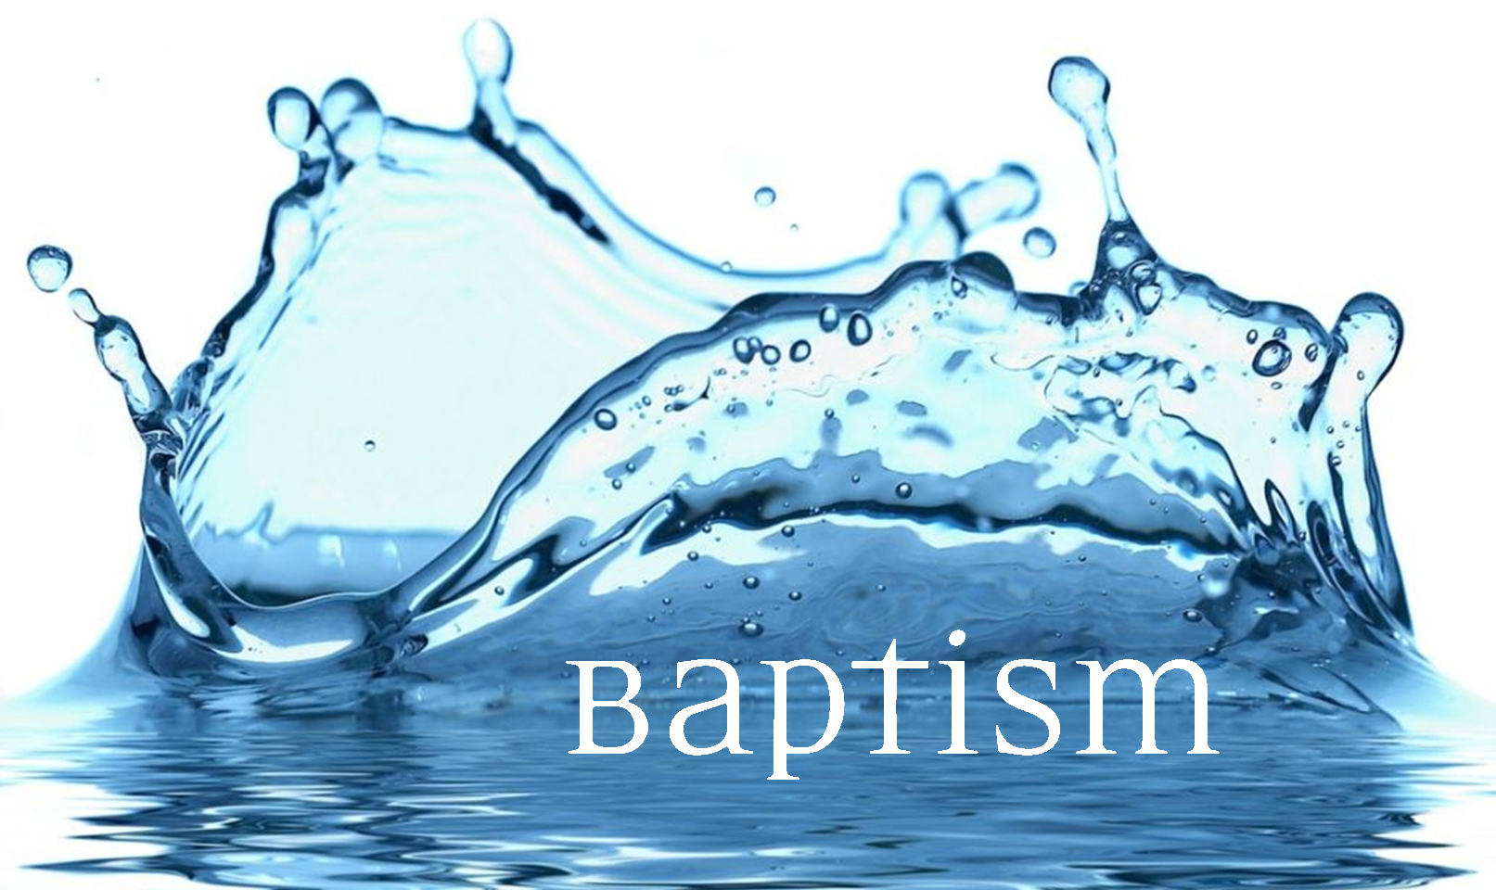
What Is Baptism?

Baptism is water and the words of Jesus. In baptism we are claimed for Jesus Christ. It is a holy moment in which someone is welcomed into Immanuel congregation and the worldwide Christian church. It is a time when the Holy Spirit does something special. The ancient word “baptidzo” means “wash”. The water reminds us of the new life that comes from Christ’s death and resurrection. Although some churches vary the method of baptism, it is the psame gift in all churches that believe in Jesus Christ. So it’s not about being “Lutheran”, it is about joining the ‘Body Of Christ’.

What Is ‘Christening’ And Is There A Difference?

In Australia the word ‘Christening’ has been used for a variety of things that people do to celebrate a birth. But we prefer the word ‘baptism’ because this is what Jesus did, it’s the word in the Bible, and it has more meaning. When we baptise someone this is a powerful and spiritual thing. It’s a part of welcoming someone into a life of following Jesus Christ. It’s not just a party to celebrate a birth – we believe it is about something deeper: rebirth!

How Do We Prepare For Baptism?

Because baptism is a huge gift from God we don’t take it lightly. Because of grace (God’s unconditional love for sinners) we don’t say “no” to requests for baptism. But a natural part of Baptism is learning about Jesus and following him in your life. So as a part of the baptism we:

- Meet with the pastor to get to know each other and discuss baptism
- Attend our baptism information afternoon or evenings.

Please call or email our office on 5445 6894 or office@ichurch.net.au

When And Where Do We Baptise?

Because it’s about being welcomed into the Christian community, we usually baptise at a worship service of the church. After you’ve done the baptism course you are welcome to work out a date with Pastor. Due to the large number of baptisms in our community we can now only do baptisms on the first Sunday of each month.

What Are Godparents?

Many people chose godparents to be a mentor or role model for a child. But in baptism followers of Jesus choose godparents to take a spiritual role. This can’t be done unless Godparents themselves have an alive faith in Christ. So it’s important for godparents to be learning about Christ and growing spiritually. If you’ve been asked to be a godparent, then this is a call from God to develop your faith!

Parents & Godparents Promises

When an adult gets baptised (perhaps this is you?) they also publicly declare their faith and promise to follow Christ. When a child is being baptised we ask parents and godparents to promise that they will help the child learn of Jesus and guide them towards the ‘confirmation’ of their faith. The baptism promises mean that you will include Christ in your everyday life and relationships. They include bringing the child to worship to learn and grow in faith.

What The Bible Says About Baptism:

The Bible says many things about baptism. But the biggest things are:
- Baptism is like a new life and new birth
- Baptism is becoming a disciple – a learner or student of Jesus
- Baptism is being welcomed into a new family with Christ

Matthew 28:18-20
Then Jesus came to them and said, "All authority in heaven and on earth has been given to me. Therefore go and make disciples of all nations, baptizing them in the name of the Father and of the Son and of the Holy Spirit, and teaching them to obey everything I have commanded you. And surely I am with you always, to the very end of the age."

Romans 6:4-5
We were therefore buried with him through baptism into death in order that, just as Christ was raised from the dead through the glory of the Father, we too may live a new life. If we have been united with him like this in his death, we will certainly also be united with him in his resurrection.

Luke 3:21-22
Jesus himself was baptized. As he was praying, the heavens opened, and the Holy Spirit descended on him in the form of a dove. And a voice from heaven said, "You are my Son, who I love and I am pleased with you."

A Baptism Ceremony

Welcome And Introductions

We Read From God’s Word (a reading which the family often choose)

Baptism Bible Reading: Mark 10:13-16

Presentation Of Child At Altar And Prayer Of Thanksgiving

Parents & God-parents Vows:

Parents and sponsors: Since you have brought this child to be baptised, you are responsible for their growing up in The Faith. Remember her/him in your prayers.

Will you set an example of Christian living for this child?
Will you pray for and with this child?
Will you remind this child of their baptism and them discover what it’s true meaning?
Will you bring this child to God’s House and teach them God’s Word?

We Declare Our Faith

Laying On Of Hands And Blessing

Signing Of The Cross And Annointing With Oil

Baptism With Water

Some Other Special Things!

A Time Of Prayer For The Baptised Person & Family

Welcome & Gifts

