Baptism Of Adults & Teens At Immanuel
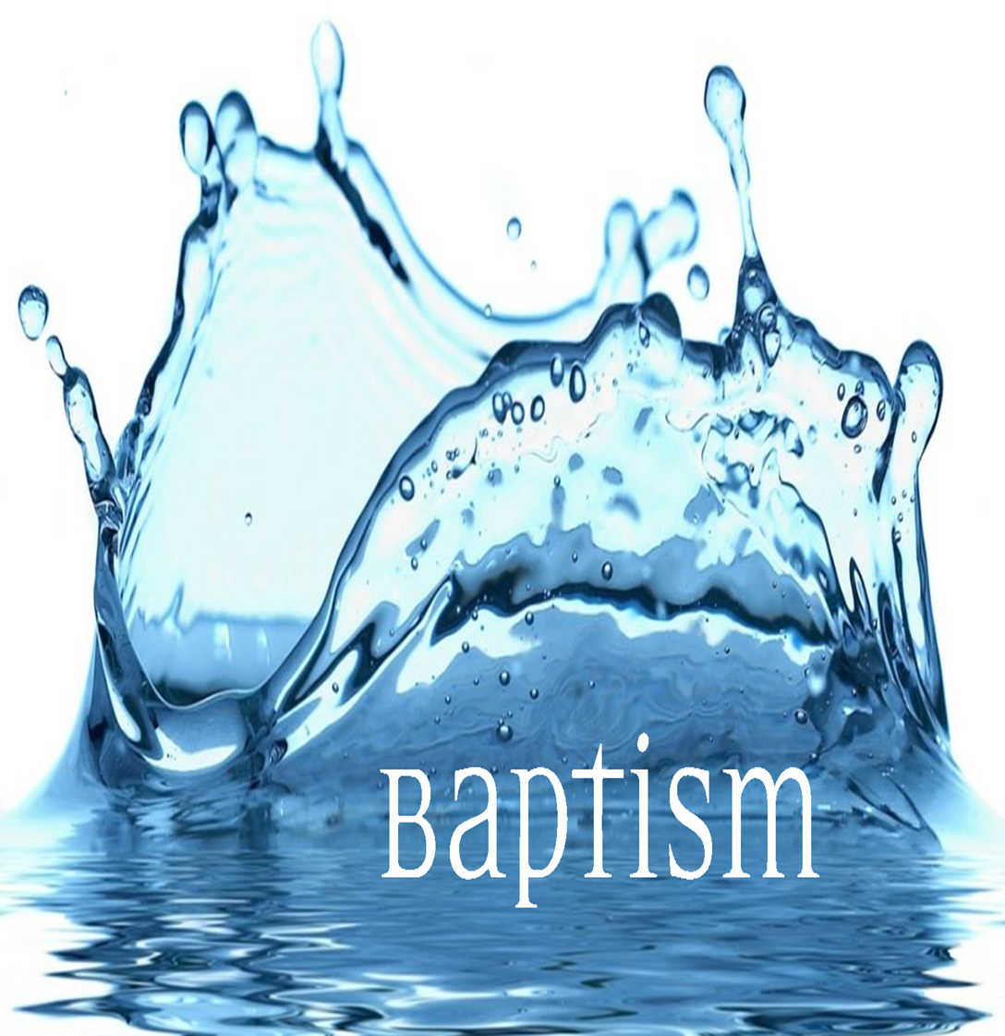
If you are thinking of getting baptised we are excited for you! It is important for you to have support in this. So the first thing you need is a team. We’d like to help you find a group of people to support you as you prepare and to ‘look out for you’ after the baptism too. Team members can include friends, anyone you respect or admire of your age and should also include someone more mature in faith who can support you in the journey to come. This brochure has three things to think over and discuss with your team…

When Can I Get Baptised?

First you need to get together with your ‘baptism team’ and with one of our leaders to discuss what’s in this guide. You don’t have to understand everything, but simply to follow Jesus and know his love.

1. Baptism Is Becoming Christ’s Learner.

Matthew 28:19-20
Our Lord Jesus Christ says: “All authority in heaven and on earth has been given to me. So go and make disciples of all nations, baptising them in the name of the Father and of the Son and of the Holy Spirit, and teaching them to obey everything I have commanded you. And surely I am with you always, to the very end of the age.”

What in here is interesting, significant, strange or special o you?
If baptism is about ‘making disciples’ what is a disciple?
How does a ‘disciple’ relate to their ‘teacher’?
What belongs with baptism? What follows baptism? What am I committing to?

2. Baptism Means The Past Is Washed Away!

Romans 6:4-11
For we died and were buried with Christ by baptism. And just as Christ was raised from the dead by the glorious power of the Father, now we also may live new lives. Since we have been united with him in his death, we will also be raised as he was. Our old sinful selves were crucified with Christ so that sin might lose its power in our lives. We are no longer slaves to sin. For when we died with Christ we were set free from the power of sin. And since we died with Christ, we know we will also share his new life. We are sure of this because Christ rose from the dead, and he will never die again. Death no longer has any power over him. He died once to defeat sin, and now he lives for the glory of God. So you should consider yourselves dead to sin and able to live for the glory of God through Christ Jesus.

Meditate on these words. What in here is meaningful to you? It’s like in baptism we get a ‘new history’. Our old life is washed away – it’s dead and we are free from the past. What do you make of all this? Martin Luther said that when we get a new life in baptism we should remember it every day. We should offer God our best, knowing that we will not always get it perfect, but knowing God just wants our best. This new life is one where we can be new every day and start again any time. Luther said... “Baptism means that our old sinful self... should be drowned through daily repentance, and that every day a new self should rise to live with God in holiness forever.” (Martin Luther’s Small Catechism)

3. Baptism Welcomes Us Into A New Family.

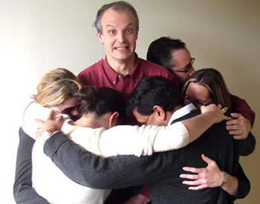
Luke 3:21-22
Jesus himself was baptized. As he was praying, the heavens opened, and the Holy Spirit descended on him in the form of a dove. And a voice from heaven said, "You are my Son, who I love and I am proud of you."

In baptism God says three things to you:
- You are my beloved child
- I love you
- I am proud of you!
Which of these three means the most to you at the moment?
Baptism doesn’t just change your relationship with God... it also changes your relationship with other people too! Here’s how.

Galatians 3:26-28
You are all children of God through faith in Christ Jesus for all of you who were baptized into Christ have clothed yourselves with Christ. There is neither Jew nor Greek, slave nor free, male nor female, for you are all one in Christ Jesus.

When you get baptised you get a new family too.
What are you going to do with that?

A Baptism Ceremony

Welcome And Introductory Words

Explaining What Baptism Is From The Bible

Baptism Person’s Story

The person being baptised shares why they want to get baptised and what God has done in their life. Three ancient traditional questions are asked too:
- Do believe in God, Father, Son and Holy Spirit?
- Do you intend to follow Jesus in your life with your best?
- Do you renounce all evil powers and ways?

If There Are Sponsors/Mentors

If there are god-parents or mentors they will be asked to make a commitment to support and help the person grow in faith.

Laying On Of Hands

We lay hands on the person and pray for them to be filled with the Holy Spirit.

Anointing With Oil

The baptism person’s supporters put a cross of oil on the person’s forehead. This ancient practice was done for kings, prophets and priests. It means that you are special and you have been chosen for something special in life.

The Baptism

The Lord’s Prayer

We pray the Lord’s Prayer over the person being baptised. This prayer brings together all our hopes and dreams for the person’s future.

Welcome & Encouragement

We give gifts and people there can offer some special words of encouragement.

